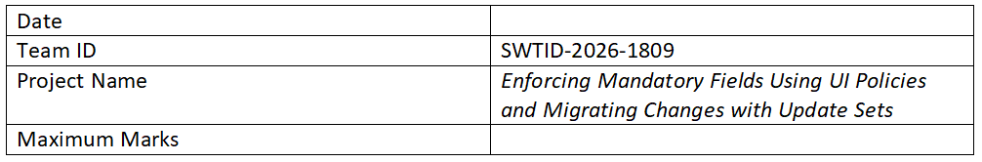

Ideation Phase

Define the Problem Statements
Date:
Team ID:
Project Name: Enforcing Mandatory Fields Using UI Policies and Migrating Changes with Update Sets
Maximum Marks: 2 Marks
Customer Problem Statement Template:
Create a problem statement to understand your customer's point of view. This helps focus on what matters to create effective solutions.

Problem Statements (PS)
- PS-1
I am: A ServiceNow user/admin
I'm trying to: Ensure important fields are filled while submitting forms
But: Users often skip mandatory information
Because: There is no proper enforcement on the UI level
Which makes me feel: Frustrated due to incomplete and inconsistent data
- PS-2
I am: A developer working in multiple ServiceNow environments
I'm trying to: Move configurations from development to production
But: Changes are not tracked properly
Because: Update sets are not managed correctly
Which makes me feel: Concerned about deployment errors and data loss

